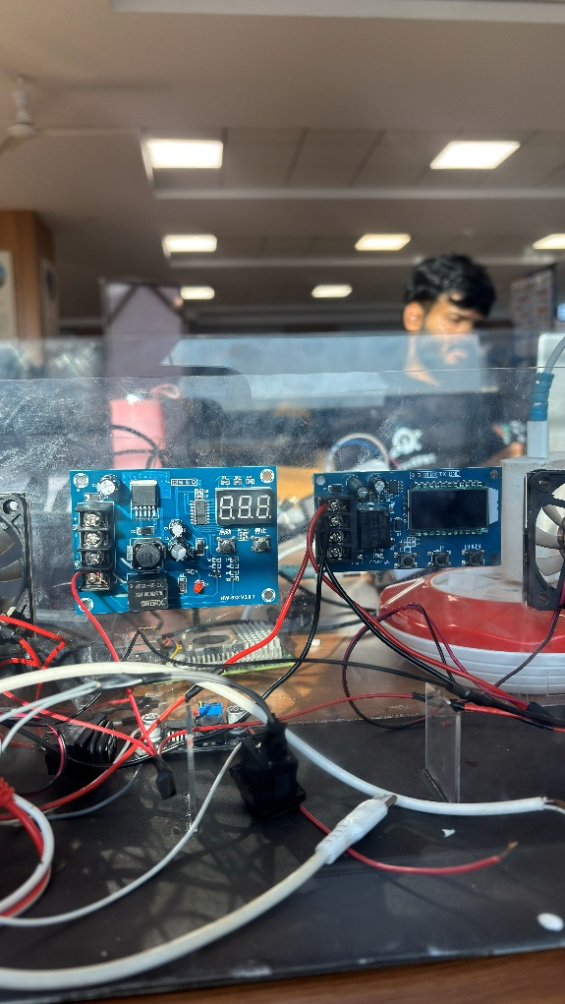
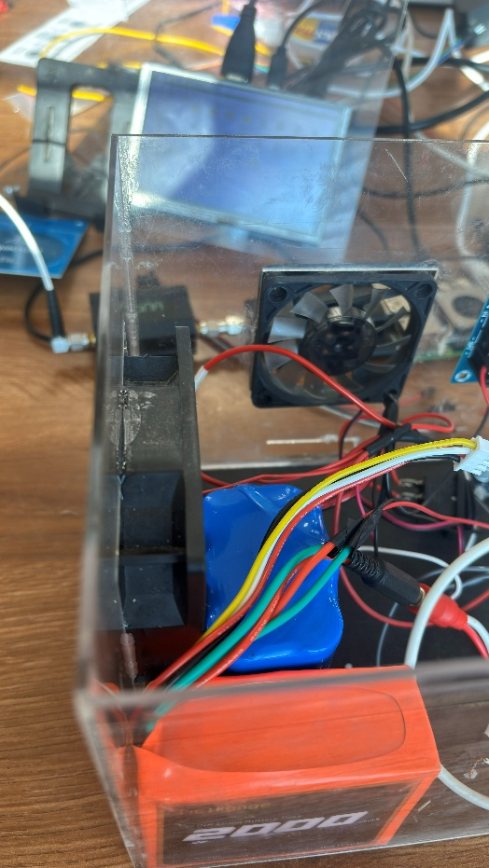
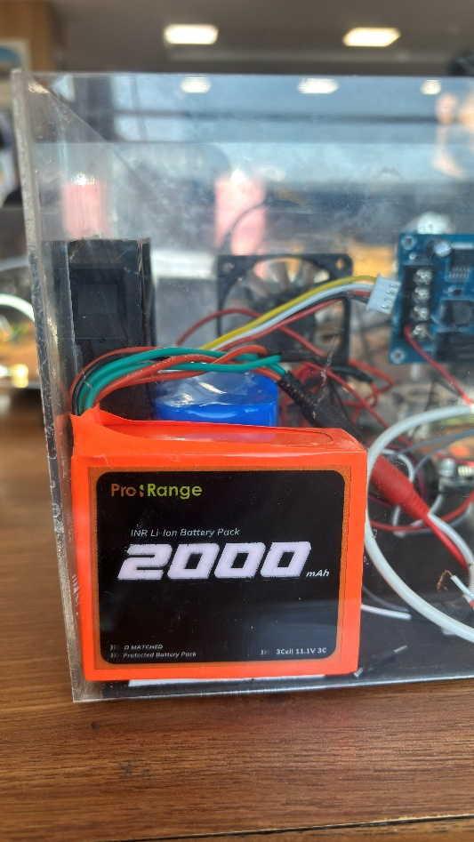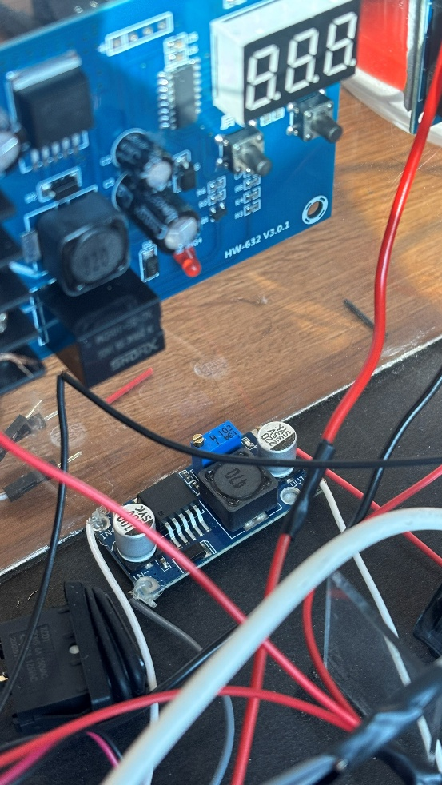
Voltage Regulator battery
Charge controller for battery
4000 MAH Lithium ion battery
2000 MAH Lithium ion battery
11.1 V to 5V DC buck convertor

